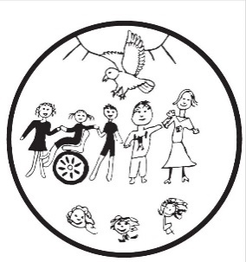
Lancasterian Primary School
A safe and welcoming learning community where:
- we all aim high;
- everyone is included;
- creativity is valued.
King’s Road, Tottenham, London, N17 8NN

Tel: 020 8808 8088, email: admin@lancs-pri.haringey.sch.uk
Head Teacher: Paul Murphy
Deputy Head Teacher: Charlotte Clinton

Phonics Pack for KS1 children:
Dear parents/ carers,

We hope you and your family are well. It is important that children remember their phonics in order to help them in all areas of learning for the return to school in September.

With this in mind, we are sending all KS1 children some resources to help them with their phonics and reading.
There are sounds in the pack that will be familiar to your child and repeating this is key to helping their reading (but you only need to do this for around 10 minutes a day). You could write words from the list on pieces of paper/ post it notes and read a few words a day or play sorting games such as real words or not real words.
Please see this website with some fun ideas to help: https://www.teachwire.net/news/5-of-the-best-phonics-games-for-eyfs-and-ks1
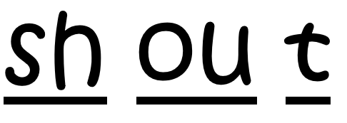
Attached to this letter are some word banks. The words can be broken into individual sounds, just like this:

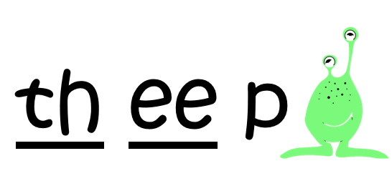
You will find some words that aren’t real (alien words), just like this:

This link will take you to a support video with how to say the sounds:
https://www.youtube.com/watch?v=IwJx1NSineE
Here are some more links to help support your child’s phonics skills at home through some fun interactive games:
http://www.letters-and-sounds.com/
https://www.phonicsbloom.com/
To support your child’s reading skills please:
- read books you have at home
- read books from the local library service (Coombes Croft Library https://www.haringey.gov.uk/libraries-sport-and-leisure/libraries/coombes-croft-library)
- or use one of these fabulous free online libraries in order to read
https://www.oxfordowl.co.uk/
https://www.storylineonline.net/
see attached PDF for google classroom library
We hope this will help your child to practise their phonics and reading skills.
Have a wonderful summer break and we look forward to seeing you in September

Kind regards,

Rachel Turnbull
EYFS phonics and literacy leader
