English and maths activities.
Answers for Thursday’s 10-minute Workout 67
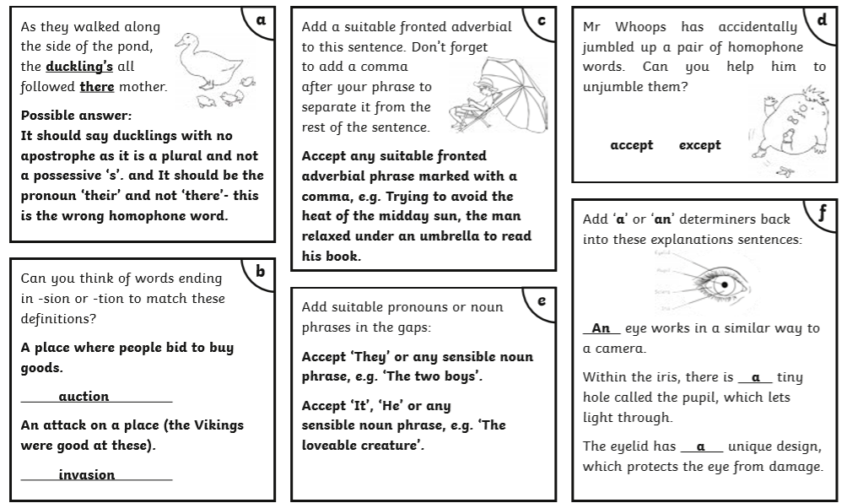
Answers for Thursday’s Reading Comprehension
Teddy’s Trip on a Train
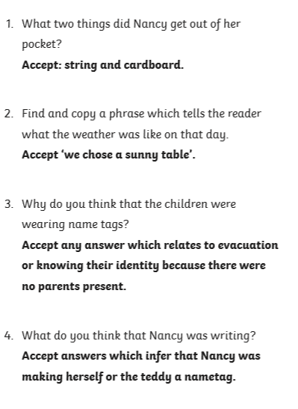

Math Work – Thursday 16th July Answers
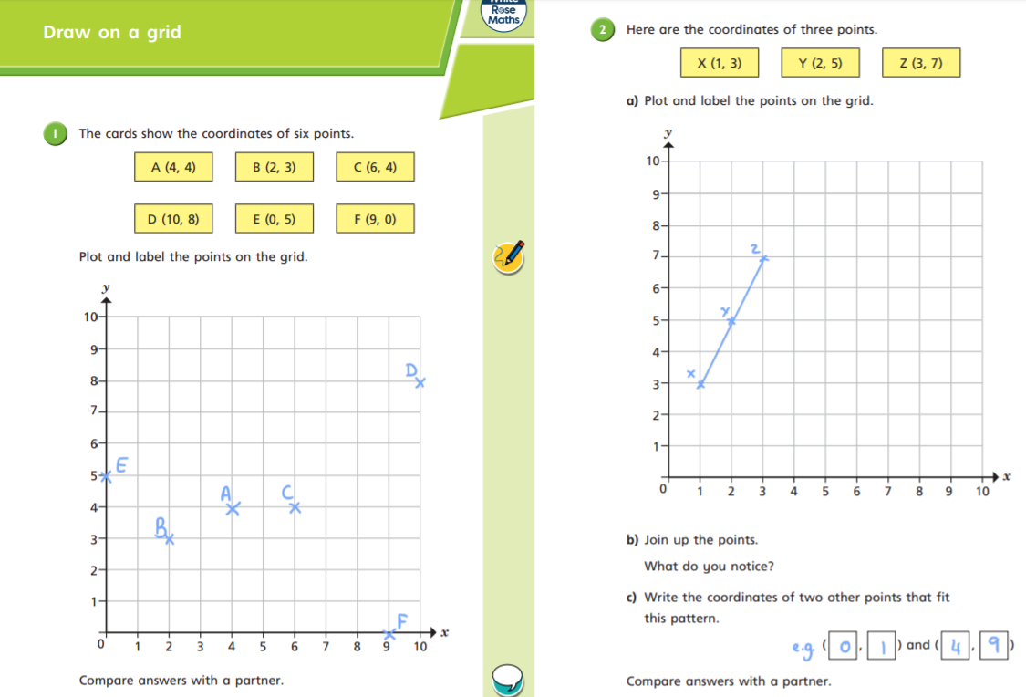
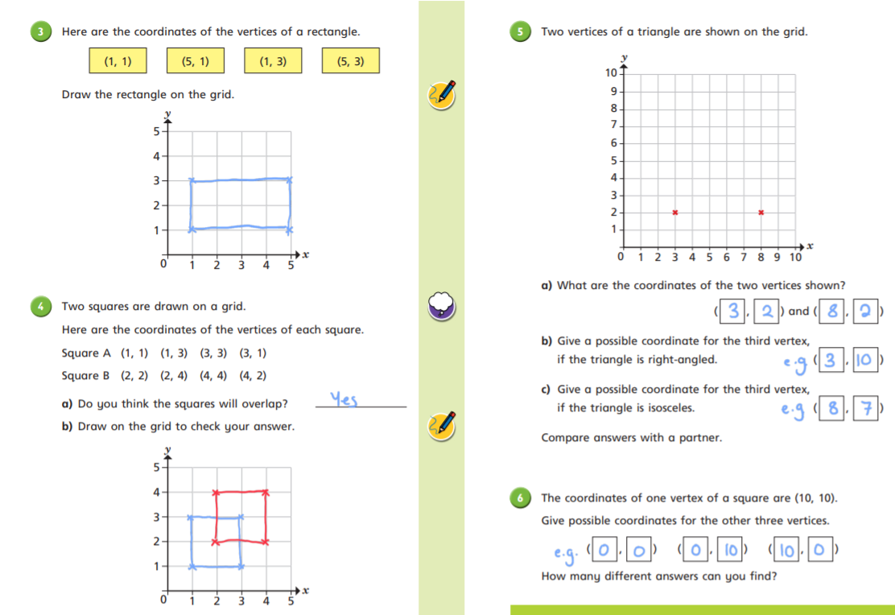
Challenges – Answers for Thursday 16th July 2020
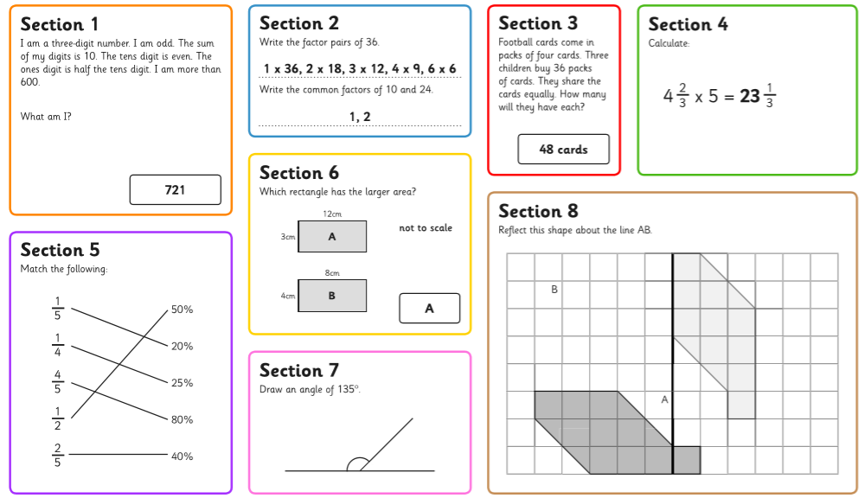
Don’t forget to also be practising on Times Table Rock Stars!
https://mathsframe.co.uk/en/resources/category/22/most-popular

