Thursday 16th July 2020

Dear Parents and Reception Children,

Please take some time to have a go at some of the fun, outdoors and creative activities you could do over the Summer Holidays with your children.

Phonics
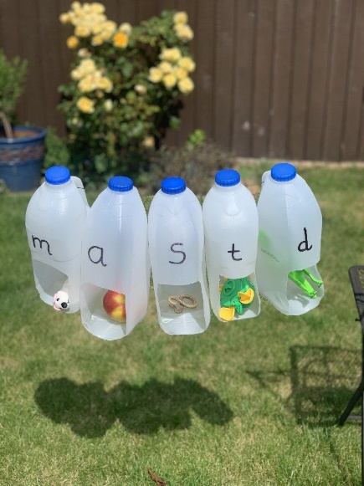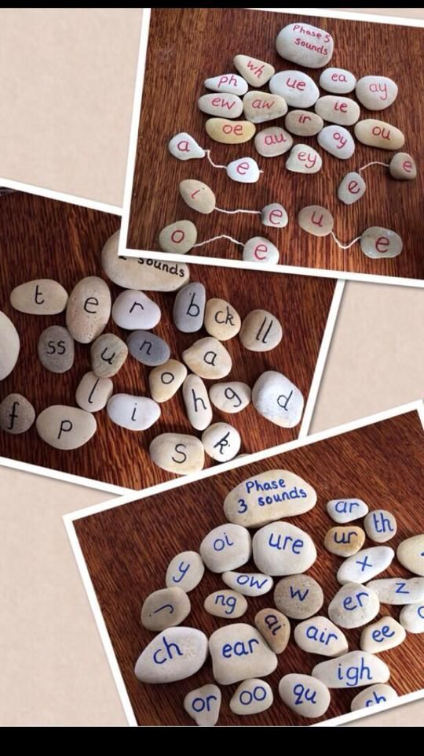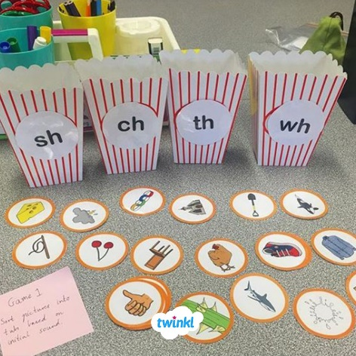

Maths

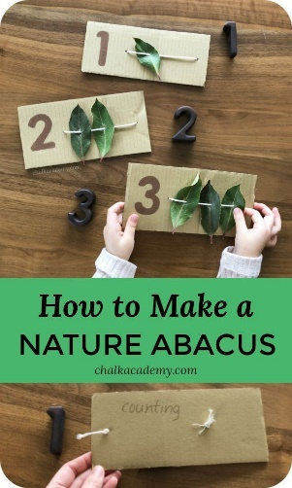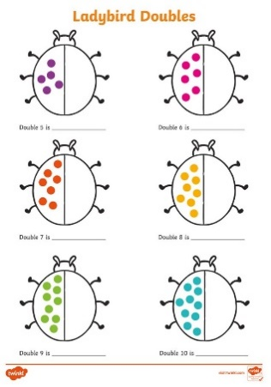

Expressive Art, Exploring the World

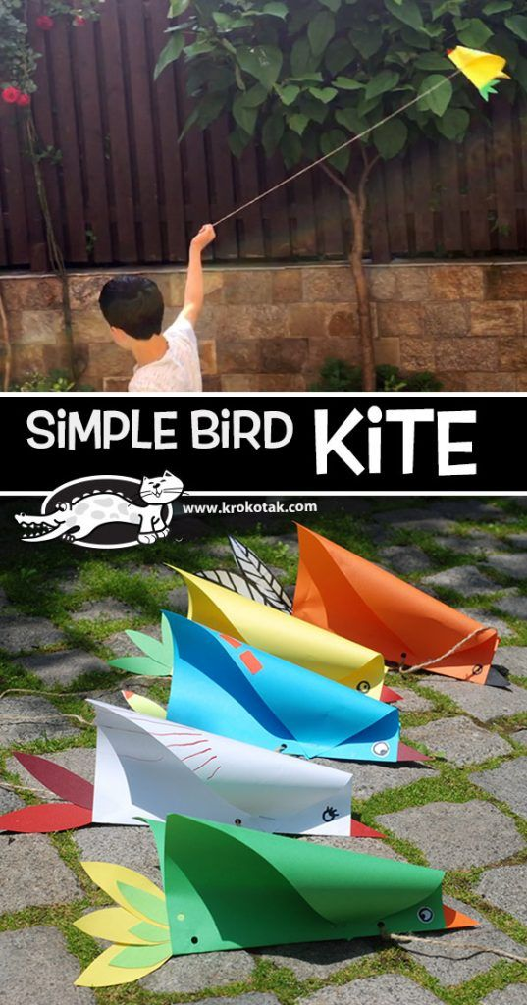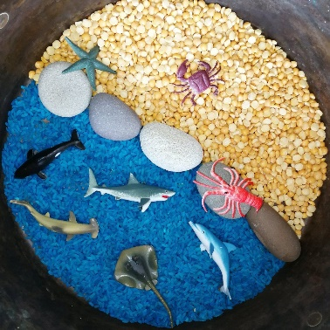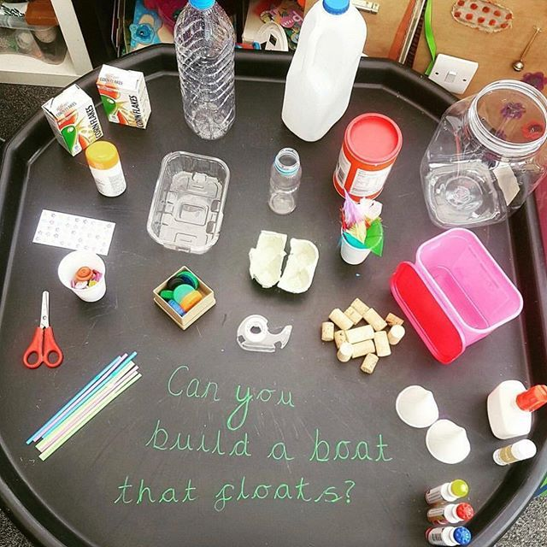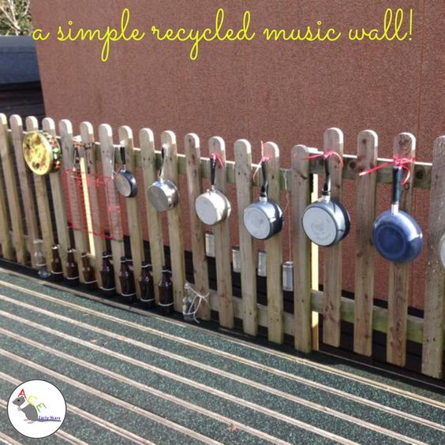

Things To Do

We know that puplic spaces have noy been so puplic in recent months. However, Time Out London has created a list of 101 things to do this summer in London. Check out the website to find out more – but here is a list of a few things you can do for free!!

https://www.timeout.com/london/kids/diana-princess-of-wales-memorial-playground

Time Out says
Friendly warning! We're working hard to be accurate. But these are unusual times, so please check that venues remain open.
This commemorative play area is easily the best bit of Kensington Gardens for a child. The popular playground for kids aged up to 12 now includes a sea monster sculpture, giant swing, turtle drum, storyteller's chair and tree carving by Daniel Cordell. Created in 2000, the area's main attraction is still the vast wooden pirate ship sailing a sea of sand. When children tire of competing for control of the ship's wheel and escapades involving cabins, pulleys and ropes there is a trio of tepees and a tree-house encampment with walkways, ladders, slides and ‘tree phones’ to provide inspiration for other imaginative games, and delightful play-sculptures hidden among the greenery that makes the place a treat for adults, too. Much of the equipment has been designed for use by children with special needs, including those in wheelchairs.
The provision of loos, nappy-changing facilities and a café makes this a place where it's easy to hang out for hours. There’s also plenty of seating for parents, and unaccompanied adults aren’t allowed in. A programme of free entertainment includes visits by clowns and storytelling sessions; check the website for details. Time your visit carefully as the playground can get very busy at the weekend if the weather's fine.

https://www.timeout.com/london/museums/science-museum
Friendly warning! We're working hard to be accurate. But these are unusual times, so please check that venues remain open.
The Science Museum features seven floors of educational and entertaining exhibits, including the Apollo 10 command module and a flight simulator. The Wellcome Wing showcases developments in contemporary science, medicine and technology. The Medical History Gallery in the museum's attic contains a substantial collection of medical history treasures. Pattern Pod introduces under-eights to the importance of patterns in contemporary science and Launch Pad is a popular hands-on gallery where children can explore basic scientific principles. Exhibits in the Exploring Space galleries include the three-metre-high, 600kg Spacelab 2 X-ray telescope that was flown on British space missions and full-scale models of the Huygens Titan probe and Beagle 2 Mars Lander. The Clockmakers' Collection, previously held at the Guildhall, is the oldest display of clocks and watches in the world, with most of the 1250 exhibits dating from between 1600 and 1850.
The museum’s in-house IMAX cinema shows scientific films in 3D, allowing visitors to be surrounded by space or submerged in the depths of the ocean. Tickets start at £11 for adults and £23 for a family of three, and booking is recommended. The shop is worth checking out for its wacky toys, while the Dana Centre is the Science Museum’s adults-only centre for free lectures and performance events on contemporary scientific issues (www.danacentre.org.uk).

https://www.timeout.com/london/attractions/crystal-palace-park

Time Out says
Friendly warning! We're working hard to be accurate. But these are unusual times, so please check that venues remain open.
Children going through the dinosaur phase always enjoy a visit to ‘the monsters’ – five dinosaur sculptures that lurk among the trees around the lake. The remains of a Victorian prehistoric theme park created on the site by Benjamin Waterhouse-Hawkins, the dinosaurs were restored in 2003.

https://www.timeout.com/london/attractions/granary-square

Time Out says
Friendly warning! We're working hard to be accurate. But these are unusual times, so please check that venues remain open.
Filled with choreographed fountains (1,080 water spouts, operating 8am-8pm daily, and lit in many colours at night), the square’s terracing down to the canal is populated most sunny days. No wonder: there’s a ready supply of students from Central Saint Martins, which in 2011 moved into the building behind- a sensitively and impressively converted, Grade II-listed 1850s industrial building. The square is also home to the House of Illustration – a gallery an education space dedicated to promoting and celebrating illustration.

https://www.timeout.com/london/attractions/london-wetland-centre

Time Out says
Friendly warning! We're working hard to be accurate. But these are unusual times, so please check that venues remain open.
The 145-acre Wetland Centre is only four miles from central London, but feels a world away. Quiet ponds, rushes, rustling reeds and wildflower gardens all teem with bird life – some 150 species. There are over 300 varieties of butterfly, 20 types of dragonfly and four species of bat. At intervals along the serene walkways are hides where you can perch on a bench, push open a small window and gaze at all manner of birds up close through your binoculars. The centre offers all sorts of entertainment for all ages, including tutored bird and otter feeding sessions, wildlife photography courses and drop-in family activities. You can explore water-recycling in the Rain Garden or try the interactive section: pilot a submerged camera around a pond, learn the life-cycle of a dragonfly or make waves in a digital pool. There are lots of places to picnic and a café with an outdoor terrace.

Take care

Early Years Team
Leisel Ciara and Holly

