Nursery home learning week 12 Friday 10th July 2020

Phonics
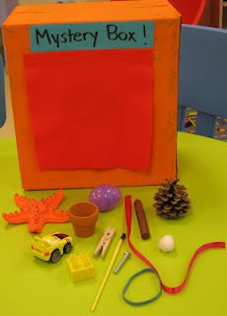
Continuing this week with the ‘I Spy” theme, create a fun mystery box and as your child takes an object of the box encourage them to use their knowledge of initial sounds.
Saying I found a.. C car. How many can your child get right?

Reading

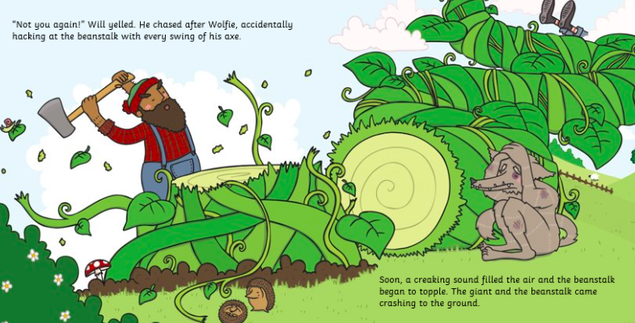
Take a look at this page in the story.

Did the Wolf have a happy ending in this story?
What happened to the beanstalk?

Key vocabulary to focus on:

Woodsman - a person living or working in woodland, especially a forester, hunter, or woodcutter.
Cottage - a small house, typically one in the country.
Exhausted - very tired.
Disastrous - causing great damage.

Literacy

Can you create a story map for the main character the Wolf in the ‘Fee Fi Fo Fum’

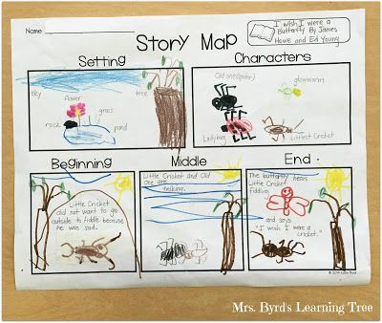

Please see the blank ‘Story Map’ form below to use to create your own story map with pictures or words. Have fun!!

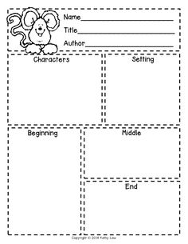

Maths

This sheet is easy to make, which helps your children understanding of number concepts.

For example the number 7 has a meaning and by one to one correspondenc, your child understand 7 means 7 objects.

Try this with other numbers up to ten.

This clip helps with one to one correspondence.
https://www.youtube.com/watch?v=QyK4aqld7Qc

Expressive arts and design

Can you create a simple image 2d shapes pebbles, sticks or any other materials you find at home.

What do you like to have on your pizza?

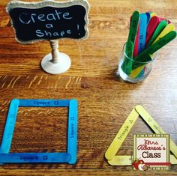

Understanding of the world

Do some cooking with your child a simple beans on toast or a more colourful bean salad.

Talk to your child about the cooking process and how food changes through cooking, peeling or cutting.

Name practise – please also use this time to practise name writing with your child every day. You could follow some of the advice on
https://www.youtube.com/watch?v=swwxOB4MS-Y

Please do not get your child to write their full name in capitals, please only use a capital at the beginning and rest of the name in lower case.

Make your name torn paper with individual letters/sounds on them. Then go on a treasure hunt for your child to be able to find the letters/sounds to create their name.

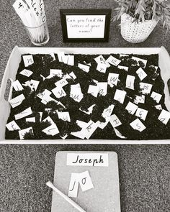
ICT links

This week’s ICT links are in the Busythings folder online. Please access this with your child's LGFL login via this link
https://www.busythings.co.uk/lgfl-login/
You will find this week's activities pinned to the home links pushpin
You will also have access to Busypaint on here too.
This is a link to LGFL’s fairy tales page, which I am sure you will find fun.
https://www.lgfl.net/learning-resources/summary-page/fairytales

You could send me a photo of your picture to:
jbadstuber1.309@lgflmail.org

