Lancasterian Primary School

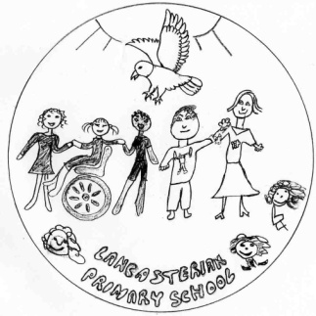

Welcome to the Early Years Foundation Stage

Early Years Foundation Stage Information

Welcome to the Early Years Foundation Stage at Lancasterian Primary School. We hope you and your child will enjoy the time you spend with us and find this information useful.

Please read this booklet carefully and keep it to refer to during your child’s time in Nursery and Reception. We are committed to working together with you to ensure that your children have a happy and successful experience during their time in Nursery and Reception. We know that children learn best when parents, carers and staff work together to encourage and support children’s learning.

We very much look forward to getting to know you and your child. The staff at Lancasterian are always available to answer any questions you may have.

Lancasterian Primary School
Vision and Values

Our Vision

We will make a fairer society.
A society where everyone can reach the top of the mountain, because all of us understand that achieving ambitions includes learning from mistakes.
A society where everyone has the skills and knowledge to open any door, because all of us break down barriers to opportunity.
A society where everyone improves the world we share, because all of us seek creative solutions to the issues we face together.

To do this, we will make the best school.
A school where every child embraces learning as a demanding lifelong journey, because all of us show them how to love challenge and growth.
A school where every child feels proud of who they are and their own uniqueness, because all of us celebrate difference.
A school where every child leaves the gate with fond memories, a creative outlook and a sense of excitement for the road ahead, because all of us have put them at the centre of everything we do.

Our Values

Inclusion
Lifelong Learning
Growth Mindset
Integrity
High Aspirations
Respect

The Early Years Foundation Stage Curriculum

The Nursery and Reception curriculum is based on the Early Years Foundation Stage Curriculum Framework. These are Government guidelines for what each child should be able to do by the end of the Reception. Both Nursery and Reception classes use this framework to plan high quality learning experiences.

All of the learning experiences we offer the Foundation Stage are through play. It is through play that young children learn to make sense of the world around them, to formulate ideas and to build relationships with others. They are encouraged to choose their activities, both indoors and outdoors. Children are encouraged to ‘have a go’ at all activities and areas of play and most importantly, to have fun! Staff plan focus activities for your children each day, which are supported by an adult. We make regular observations of the children and use these to plan activities to develop their skills, based on what the children can and like to do.
The Unique Child
Every child is unique, is consistently learning and can be resilient, capable, confident and self assured.

Positive Relationships
Children learn to be strong and independent through positive relationships.

Our Early Years curriculum is based four themes underpinning the Foundation Stage guidance

Enabling Environments
Children learn and develop well in enabling environments, in which their experiences respond to their individual needs. There is a strong partnership been home and school.

Learning and Development
Children are challenged and experience opportunities across the areas of development.

The Seven Areas of Learning and Development

Opportunities for learning are provided in the following areas:

- Personal, Social and Emotional development
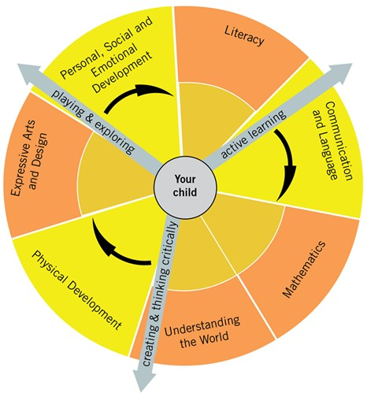
- Communication and Language

- Physical Development

- Literacy

- Mathematical Development

- Understanding of the World

- Expressive Arts and Design

Personal, Social and Emotional Development
For children to be successful in all areas of learning, they need to feel secure and to develop a positive sense of themselves. Much of our provision is based on the need to provide opportunities for personal, social and emotional development.

Children will:

- Respect themselves and others and develop a positive self image
- Take turns and share
- Feel confident to take risks and cope with mistakes
- Make friends and co-operate in a group
- Develop a positive attitude to learning
- Understand and embrace differences in gender, special needs, ethnicity, religion and cultures

Communication and Language:
This area of learning includes non-verbal communication, speaking and listening and expressing themselves effectively. Our classrooms provide many opportunities for the children’s development in this area. We use role-play, book corners, a listening area, plus a wide range of other purposeful activities to enable children to practice and develop their skills.

Children will:
- Develop the use of appropriate language in many different activities and in every part of the curriculum
- Retell and talk about texts with confidence
- Listen to a range of stories and make relevant comments or ask questions.
- Answer questions about their play.
- Express themselves and develop their ideas.

Physical Development
In the Foundation Stage, Physical Development is vital in helping children to develop a positive sense of well-being. Children learn to improve their co-ordination, control, manipulation and movement. Children learn through being active and their physical development takes place through other areas of learning.

Children will:
- Experiment with actions using small and large apparatus
- Use different resources in different situations
- Practice large and small movements both inside and outside, such as climbing and jumping and writing
- Develop their skills using small apparatus and playing games
- Discuss the importance of good health and how we can be healthy at home and school.
- Respond with movement to different stimuli, such as music, stories and rhymes

Literacy:
Children will have opportunities to listen to, retell and read a wide range of texts. They will write for many different purposes across many different areas. Children will link sounds to letters and use their phonic knowledge to write, giving meaning to their mark making.

Children will...
- Share and read a range of quality books with
adults and each other and learn how text works
- Retell and talk about texts with confidence
- Learn that words have meaning and develop
knowledge of letter sounds
- Know there are different scripts
- Communicate their ideas confidently through
drawing, mark making and writing

Mathematics
This area of learning involves counting, sorting, matching, recognising patterns, working with money, identifying shapes and measuring. We develop children’s mathematical understanding through play, songs, stories and rhymes as well as investigative and problem solving activities. At Lancasterian Primary school we are committed to a practical approach to the learning and teaching of mathematics. We believe that children will develop a firmer understanding of mathematical concepts if they are provided with a range of practical experiences which allow them to practise and develop their skills.

Children will:
- Use and recognise numbers
- Count and order numbers
- Develop an understanding of more and less
- Make simple calculations
- Become aware of, recognise and name simple shapes
Understand and compare measures and learn about
Measuring time

Understanding of the World:
In this area we help children to develop the knowledge skills and understanding to help them make sense of the world. It is the foundation for later work in Science, Design & Technology, History, ICT, Geography and Religious Education.

We give children opportunities to find out about the world around them and to ask questions. They design and make different objects using a wide range of tools and materials. We enable children to find out about the past and learn about the school and where they live. They become aware of differences in gender, ethnicity, culture language and religion. Children select and use technology for different purposes.

Children will:
- Develop their skills to use and explore a variety of tools
and materials
- Investigate how things work
- Learn about living and non-living things
- Measure, join, cut, select and combine materials
- Have opportunities for exploration, observation,
problem-solving, prediction, critical thinking,
decision making and discussion.
- Use technology for a variety of different purposes.

Expressive Arts and Design
This area of learning includes art, music, dance, role-play and imaginative play. Throughout the Foundation Stage, children need many and varied opportunities to develop creatively. It is an important area of the curriculum, as being creative enables children to make connections between one area of learning and another.

Children will:
- Express their creativity and originality through music, art and imaginative play
- Develop an appreciation of art and music from different cultures
- Experiment and work with a range of different techniques and materials to express their ideas
- Explore making sounds with their bodies and with instruments
- Talk about their work and develop confidence to express their ideas
- Respond with movement to music and songs

We hope that the information included in this booklet has helped you to understand how we will be working together to give your child the best possible education and to let you know how you can help at home. Please do not hesitate to speak to a member of staff or email the school if you have any questions: admin@lancs-pri.haringey.co.uk

The Nursery

We provide both full-time and part time places for Nursery children. The children in the Nursery are 3 and 4 years of age and you can apply to Haringey Council for a Reception place in the September after their fourth birthday.

Our staff are all highly trained to work with young children and we have a Nursery Teacher and a Nursery Nurse in each session.
Nursery Hours

Part time pupils
Nursery Hours are from 8.45am until 11.45am for morning nursery. Nursery hours for afternoon children are 12.45pm until 3.45pm. Please bring your child to Nursery on time. This will help your child in adjusting to the new routine. Please remember also to collect your child promptly. It can be very distressing for a young child to be left at school when all their friends have gone home and it can make him or her reluctant to return again.

Full time pupils
We have full time nursery places available for pupils eligible for the 30 hour funding and for fee paying full time places. The core day is from 9am- 3pm but parents can pay for their child to stay for longer for an additional fee.

Settling in

We want your child’s start in the Nursery to be happy and secure so we stagger the children’s start dates so that they begin Nursery in small groups. This enables staff to spend time helping the children to settle and allows them to give more attention to each new child at this very important time in their lives. For many children starting Nursery is a very big step especially if they have not attended a Nursery or child care previously. We make the transition from home to school gradually to help the children settle.

Every child is unique and every child is different. With this in mind, we tailor an individual plan for settling in. This will be discussed with you during your child’s first few days.
Each child is different and we will work with you to decide what is best for your child to support them in settling. For some children who are finding it difficult to settle into nursery, we will set up a bespoke settling in programme for them.

If your child has been allocated a full-time place they will initially start part time, until they are ready to attend a full day. This may take a few days or a few weeks.
We start this process by:

- First full time day - stay for lunch and leave at 1.00pm
- Second full time day - stay for lunch and leave at 1.00pm
- Third full time day – stay for lunch and leave at 2.00pm
- Fourth full time day – stay for lunch and leave at 3.00pm
- Officially full time from this point (children stay until home time)
Lunchtime is often the most difficult time for children when they start school so do not be surprised if they come home very tired after lunch.

The decision to stay for the whole day will be made by the staff, in consultation with yourself. Some children take much longer than others to settle so we will extend the settling in period if needed depending on the child.

Hometime

At home time you should wait outside the nursery building at the nursery entrance next to Bruce Castle Park. The children are dismissed from the door when the teacher has seen their adult.
Please remember if you have older sibling in the school to collect them first, as the school day finishes earlier than the nursery

When the team dismiss the children please make sure that you wait near the wall of the park and not too near the nursery gate. This makes it easier for staff to see who is waiting. Please also remember not to call out your child’s name as this makes it more difficult for the staff to dismiss the children. If you have anything you would like to discuss with the team, at the end of the day, please wait until the team has finished dismissing the children and then a member of the team would be happy to speak to you

Reception

There are two Reception classes and each class has a Class teacher and Nursery Nurse.

Starting school can be unsettling for children after the holidays especially if they are coming to Lancasterian from a different Nursery or they haven’t had the experience of attending Nursery. For this reason the children will start in Reception in small groups to ensure that the staff can give the children the attention that they need in order for them to settle as happily as possible. Each week a new group of children will start and slowly become accustomed to the full time day. After attending reception for a few days we will ask the children to stay for lunch and leave at 1pm. If your child is ready, we will extend this to a full day. We appreciate that this can be difficult for working parents but experience has shown that this is the most effective way for all children to have a positive start to school.

If you have any concerns about how your child is settling or you feel that they may need to attend part time for longer please speak to the staff and we will discuss what will be best for your child to help support their transition to Reception. The staff may feel that a longer transition period is necessary for some children, in which case we will discuss this with you.

At home time, once your child is staying all day, you should queue outside the classroom at 3.20 pm. The children are dismissed from the door when the teacher has seen their adult.School starts at 8.50am. It is important that your child arrives at school promptly and ready to start the day. If your child is late, you need to report to the office so they can be entered into the register.

Important Information

Starting school is a big step in your child’s life and we wish the settling in process to be as smooth as possible. Please take the time to read this section of the booklet, as it will answer some of the questions you may have. If you have any further questions or queries please do not hesitate to contact a member of staff at school.

What happens at lunchtime in Nursery and Reception?
Your child may have school lunch or bring a packed lunch to school. Reception pupils are entitled to a free school meal. If they bring a packed lunch it should be clearly labeled with their name. Packed lunches should consist of healthy food with no nuts, fizzy drinks or sweets. The children eat their meals in the dining hall for Reception and in the Nursery for the Nursery children. They are looked after by the Mealtime Supervisors.

What happens if my child is unwell at school?
Children who become ill during the school day are looked after by the first aider and if necessary, parents or carers will be contacted and asked to collect the child from school. It is very important that we have a contact telephone number where we can contact you during the school day.

What should I do if my child is unable to attend school?
Government regulations require parents or carers to explain every absence from school. If your child is absent or late, please telephone the school office to inform us on the day that they are unwell. If you wish to take your child out of school in term time, you will need to request leave of absence in writing to the Head Teacher. You must make sure you have permission from the Head Teacher before taking your child out of school. Holidays are not authorised during term time.

Parent Helpers
Your active participation in the Early Years Foundation Stage is welcomed at all times. You can be involved in sharing a skill such as cooking, gardening, carpentry, sewing etc. Playing games or reading stories to the children are other valuable ways of contributing to the daily routine at school. All helpers will be required to attend an induction session with the Assistant Head Teacher. If you would like to come and help in school, please speak to your child’s teacher.

Parent Workshops
We believe in working together with parents and carers to support the children’s learning. We run regular sessions in Nursery and Reception for parents to attend along with their children; this is an effective way for us to share what we are teaching and how we teach it so that parents will know how to support at home. This enables us to work together to help the children to make the best progress possible. Throughout the year, we will run sessions for parents of reception pupils on how to support your child as they learn to read. If you have any queries or concerns about how you can support your child at home, please, speak to your child’s key person in class or Julia Ryan (Assistant Head teacher).

Home/School Reading

Home School Reading
We want the children to develop a love of books and enjoy stories both at home and school. Parents and carers are invited to buy a book bag for Reception children.
In Nursery, we will provide a plastic folder for your children to take home a class reading book. This book will be changed weekly by the nursery team with your child.
In Reception, we will send home a book from our home- school reading scheme. This is a book that we expect your child to read by themselves with encouragement from you. The teacher will write comments in your child’s home/school reading diary. There is an opportunity for you to reply with comments about your child’s reading.
They will also be able to take a book from our book box that you can share together at home.
Please look after the books you borrow. If any books are damaged they will need to be paid for.

Key Person
When your child starts in the Early Years Foundations Stage, they will be allocate d a key person. This member of staff will make observations of your child, take photographs, gather evidence to share with you on their Tapestry learning journal.

Are toys allowed at school?
Children are not allowed to bring toys, stickers, large footballs to school, with the exception of a comfort toy, which sometimes children need to bring when they first start school.

Drinking Water
At Lancasterian we believe it is important that children have free access to water to keep their brains healthy. Please provide a bottle of water with your child’s name on it.

Fruit and Milk
We provide a piece of fruit each day for the children. In the nursery children also have milk. This helps the children to stop feeling hungry throughout the morning and is also an important social friendship building time for the children.

School Uniform

In Reception and Nursery the children wear the school uniform which consists of a grey skirt or trousers, a white polo shirt, black velcro shoes(no laces) and the school sweatshirt/cardigan which can be purchased from ‘’Star School Uniform’’ shop located at 32 Church Road N17 8AQ.

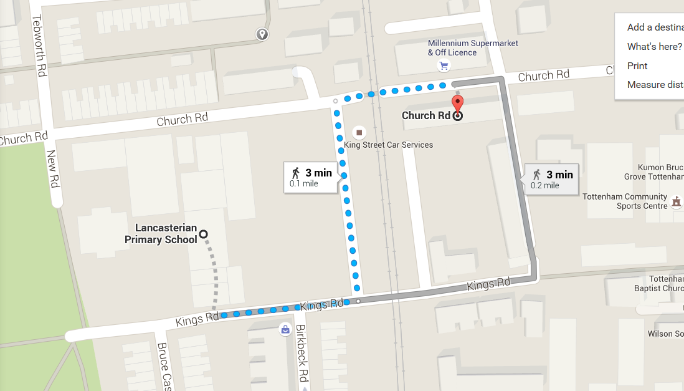

Clothing
Children in the Nursery are developing their independence with toileting, so please make sure that they wear clothes that they can manage by themselves. Staff help children to learn to manage their own clothes but we want the children to become independent in this. We encourage creative exploration, so children will frequently be using paint and water in their play. We do provide protective aprons and we help children to become independent at putting them on themselves. Sometimes children do get paint on clothing despite the provision of aprons. We ask parents to bring a full set of spare clothes in a bag to school, which will be kept on their peg in case we need to change your child.
If clothing has been used it is import to replace each item so that pants, socks, trousers and a top or jumper are always available in the child’s changing bag.

Children at this age find it difficult to remember what clothes are their own, so it is vital that you write your child’s name in every item of clothing.

The children in Nursery and Reception have free access to an outdoor classroom. It is necessary, therefore, to ensure that they are dressed appropriately. We ask that your children leave a waterproof coat at school and a pair of Wellington boots. Please provide protective clothing from the sun in the summer months, particularly a sun hat.

Physical Education
In Reception, your child will participate in P.E. Please provide navy or black shorts and a white T-shirt for when they start to have P.E. lessons.

Lancasterian Primary School
King’s Road, Tottenham, London, N17 8NN

