Lancasterian Primary School
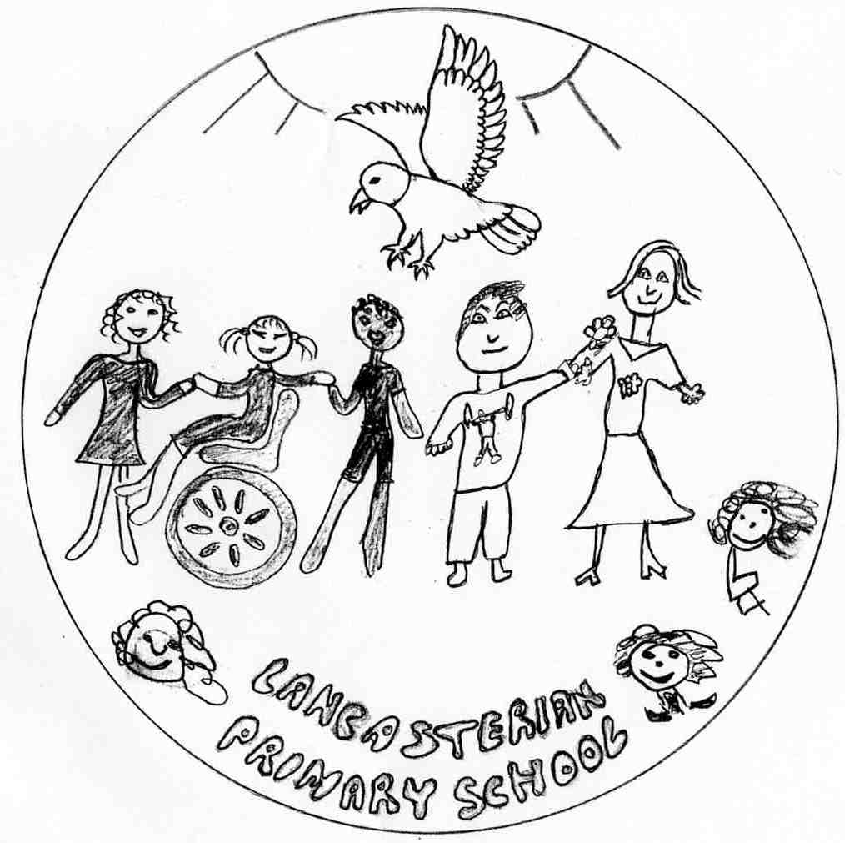
A safe and welcoming learning community where:
- we all aim high;
- everyone is included;
- creativity is valued.
Vision, Values and Strategies
This document outlines the Vision, Values and Strategies of Lancasterian Primary School.
- Our Vision is the destination, where we want to get to and why (we also have a summary, easy to remember Vision Statement – see document header above)
- Our Values are the characteristics and behaviours which we all need to ‘live’ in order to achieve our Vision.
- Our Strategies are the key drivers which underpin our Values and help to achieve our Vision.
- Below all of these sit our Three Year Goals, School Improvement Plan, Subject Leader Plans, etc.

A.) Lancasterian Primary School Vision
We will make a fairer society.
A society where everyone can reach the top of the mountain, because all of us understand that achieving ambitions includes learning from mistakes.
A society where everyone has the skills and knowledge to open any door, because all of us break down barriers to opportunity.
A society where everyone improves the world we share, because all of us seek creative solutions to the issues we face together.
To do this, we will make the best school.
A school where every child embraces learning as a demanding lifelong journey, because all of us show them how to love challenge and growth.
A school where every child feels proud of who they are and their own uniqueness, because all of us celebrate difference.
A school where every child leaves the gate with fond memories, a creative outlook and a sense of excitement for the road ahead, because all of us have put them at the centre of everything we do.

B.) Values

Value | Paired Strategy
Inclusion | Inclusive Practice
Lifelong Learning | Quality First Teaching
Growth Mindset | Child-Centred Learning
Integrity | The Right Culture
High Aspirations | Exceptionally High Achievement

B1.) Inclusion
Is it not a nonsense that we should have something called Black History Month? Ideally this should not be the case. The presence of true inclusion would deny this, throw it out of the ballpark. Inclusion for some is about special needs children in school and it’s really not just that...it’s sooooo much more. Back to Black History Month. Think about the Rosa Parks situation: to us she wasn’t setting out to be some heroine but was an exhausted and brave woman, one who was tired of being denied equality...her rights as a human being. She simply wanted to be included in society, something being denied to black people at the time (and still today to a different extent). So, Rosa Parks sat down on a bus in a section reserved for ‘white’ people. When Rosa was told to go to ‘her place’ at the back of the bus, she refused to move, was arrested, and history was challenged and changed. As she sat down she thereby stood up for inclusion!

Moving on fifty years we ask: has anything really changed? Inclusion should be an invisible thread woven through everything however one could ask, are we simply ticking the inclusion box as with Black History Month? There has been a shift, more of a focus on the so-called ‘disabled’, many people whose abilities are regularly denied or ignored feel that society is not honouring them the right to participate in society in a full way. Are we learning any lessons? We now have improved physical access through wheelchairs ramps, signs and materials in Braille, hearing loop systems, community living, etc. However, much more needs to be done catering for the hearts and minds of people who don’t feel included. As Asante says, “It is generally accepted that ‘Inclusion’ means inviting those who have been historically locked out to ‘come in’. This well-intentioned meaning must be strengthened. A weakness of this definition is evident. Who has the authority or right to ‘invite’ others in? And how did the ‘inviters’ get in? Finally, who is doing the excluding? It is time recognize and accept that we are all born ‘in’! No one has the right to invite others in!”

As the renowned inclusive theatre group Chickenshed once stated: ‘Life is good when you are in it’. And so inclusion should be the norm....only noticeable in its absence, not as it currently is.
As human beings it is our responsibility to create a society where barriers are removed. So what is inclusion? “Inclusion is recognizing our universal oneness and interdependence” (Asante). Inclusion is recognizing that even though we are not the same, we are still ‘one’. Diversity is valued. The act of inclusion means fighting against exclusion and all of the social diseases exclusion gives birth to, i.e. racism, sexism, ageism, disabilities of the mind and body etc. We need to embrace a change, with our hearts and souls, in our attitude towards inclusion.

Finally we like to remember that "An injury to one is an injury to all!" and in the case of inclusion, "The benefit to one will be the benefit of all." (Pearpoint & Forset)

B2.) Lifelong Learning
We’re going on a learning journey
We’re going to find out more
Another day to improve ourselves
We’re not scared

Oh no!
Times Tables… tricky, challenging times tables
I can’t always remember them
I can never recall them quickly enough
Hmmm… I know what I need to do
I must get practising
Then I’ll know them some more

Now we’re continuing with our learning journey
We’ll have to consider some more
Another chance to challenge ourselves
We’re not scared

Oh no!
Reading… scary, difficult reading
I can rarely read the words
I can’t ever recall what’s happened
Hmmm… I know what I should do
I need to make sure I’m listening to make sure I learn from others
Then I’ll enjoy the adventure of reading some more

So next up on our learning journey
We’re going to think some more
Another chance to try new things
We’re not scared

Oh no!
Chemistry… confusing, mystifying chemistry
I barely get to the answer
I can’t ever solve the problems
Hmmm… I know what I’ll do
I must keep on exploring
Only then will I develop my understanding

One final step on our learning journey
We must endeavour to find out more
Another opportunity to improve ourselves
We’re not scared

Oh no!
Computing… overwhelming, puzzling computing
I don’t always know how to explore
I can’t ever remember how to present things
Hmmm…I know what I must do
I must make sure I begin to research
And then I’m sure I’ll begin to improve

Now…
It’s time to finish our learning journey
We’re going to have to have some rest
Before getting up tomorrow
Another day for learning
We’re not scared!

B3.) Growth Mindset
Once there was a boy called Sam, an anxious and timid boy, for whom learning was nothing but a struggle. Sadly, he didn’t know that intelligence was something that could be grown, so whenever he faced a new challenge, he would simply say, ‘I can’t do this!’ Plodding along each day, he was always disappointed at school, because he always focused on his results, and not on the effort he had made to get them. Eventually, he became so frustrated and disheartened that he stopped trying to learn new things; he had become scared of mistakes and failure, so the idea of taking a risk to learn something new became impossible!

But then, one day Sam’s teacher, Ms Dweck, came into the classroom in a blaze of excitement and enthusiasm and announced, ‘Today, we’re going to learn all about Growth Mindset!’ She started to tell the children things that Sam had never heard before, crazy things like ‘intelligence is something that we can grow’ and ‘effort is more important than results’. Ms Dweck told the children that they were not allowed to say ‘I can’t do this’, unless they put ‘yet’ at the end of it. Excitedly, she stated that they should try to learn new things as often as they can and even seemed to be encouraging them to take risks in their learning and make mistakes – yes, a teacher who wanted her pupils to make mistakes! Sam’s head was spinning. ‘Well,’ he thought to himself curiously, ‘school can’t get any worse so I might as well give it a try.’

Three weeks later and Sam’s world has turned upside down…but in a good way. Now learning is an adventure, like running through an irresistible forest of knowledge and skills where falling over is a good thing (because it will help you become an even better runner in the future) and it doesn’t matter how far you get as long as you try your best. No more fear of failure, no more shying away from risk, Sam doesn’t mind if the work is challenging any more – in fact, he wants the work to be hard, otherwise how on earth can he improve?! And the funny thing is, even the adults at the school seem to have changed; happier somehow, and making learning more exciting. The days of school anxiety and frustration seem like a distant memory, and Sam faces the learning journey ahead with curiosity, optimism and excitement, all thanks to the Growth Mindset that Ms Dweck taught him.

B4.) Integrity
If every day
You can honestly say
Once you step through our door you are true

If in each interaction
(And not just a fraction)
It’s the same – what you say and you do

If in both work and play
You are what you say
And you always stick to your word

If alignment is neat
Through head, mouth, heart and feet
And your values are always heard

If you’re humble and fair
And there’s no ego there
And you always come back to your scruples

Then integrity’s yours
Trust will open up doors
Because you do what you do for the pupils

B5.) High Aspirations
Lisa’s Diary
Wednesday 6th September 2017 (Recorded on her My Little Pony AudioDiary)
It’s my first day in school; it’s a beautiful sunny September morning. I’m so excited waiting with Mum by the playground in our estate for Mary (my Mum’s best friend) and her a son Damien, who I play with all the time.

"Lisa look at my new shoes,” shouts Damien running towards me, "Look at mine!” I shout back. We both have lovely, shiny shoes and our uniforms are new and smelling fresh. Our Mums do everything together and so do me and Damien; we are so excited about going to our new school!

We run up the road towards school so fast, and enter through the big black gates and there are loads of children playing in the playground. “We are in big school now!” we say to each other. When our teachers come out to get us, Damien and I are shocked and a bit sad to find out we are not in the same class. “Oh well,” I say, “we’ll still see each other at playtime.”

The first thing my teacher, Miss May, asks us is, “Does anybody know what they want to be when they are older?” Some of us do know, others are a bit confused. I want to work in a zoo with lots of animals! My teacher says that is a fantastic idea and gives me a book about Old McDonald’s Farm. I draw lots of pictures! Listening to Miss May makes us really inspired to achieve our goals and not to become frustrated when things are challenging.

At playtime I ask Damien what he wants to be when grows up. He said he doesn’t know; I don’t think they talked about that in their class like we did.
…

Friday 21st July 2020 (Recorded on her My Little Pony AudioDiary)
Yay! It’s the end of year two and my TA, Sienna, says that I have done really well in my SATs – greater depth in reading, whatever that means! Sienna spent the whole year making sure that I took a book from the book corner every week, and kept telling me that I could be an amazing reader, even though I found it hard.

Damien was really sad at home time today. He hasn’t done very well in his SATs. I heard his mum say to him, “Don’t worry love, SATs aren’t important. As long as you’ve been a good boy.”
…

Thursday 10th July 2024 (Written on Diary App)
Greater depth in all my key stage 2 SATs! My mum and dad are going to be so proud. Ever since that vet came into our class in year 4 and said that if we wanted to be a vet we would have to go to university, I knew that I would have to work hard. Sue, the lunchtime supervisor, came up to me in the playground when she heard about my results and said that she was looking forward to bringing her cats to my surgery in the future!!

I didn’t really ask Damien about his results. I know he missed a couple of the tests because he was off school, like he is a lot of time. Why don’t his parents get into more trouble for that? He always used to be good at maths; maybe if an accountant had come to speak to him he would have tried harder!
…

Thursday 20th August 2029 (Written on Diary App)
I’m off to Woburn Safari Park Summer Camp!! My mum and dad said that if I did well in my GCSEs, then I could go; I got eleven GCSEs all scored above 3! I bet this is what Yusuf, our careers advisor, was planning all along when he suggested Woburn as a reward to my parents last September – very sneaky… Looks like I’ll be back again next year for sixth form!

I haven’t seen Damien for ages; he hasn’t been to school since he started hanging around with Daniel and his gang. I don’t think he even got any GCSEs. What a waste! He was always better than me at maths but somehow I got the grade 2, and he didn’t even sit the exam! I wish he’d had a chance to meet Yusuf, or that someone had spotted how good he was at algebra.
…

Wednesday 7th September 2031 (Written on Diary App)
It’s my first day in uni; it’s a beautiful sunny September morning. I’m so excited waiting with my flatmates for the bus, the girls I hand out with all the time.

"Lisa look at my new tablet,” shouts Alicia running towards me, "Look at mine!” I shout back. We both have lovely, shiny new Apple iPad 15s and our clothes are new and smelling fresh. We do everything together and are so excited about going to our first Veterinary Studies lecture! “We are in big school now!” we say to each other, laughing.

We hailed a taxi this evening to get home from the students’ union (Alicia had had one too many!) Guess who the driver was!

C.) Strategies

C1.) Inclusive Practice
A Recipe for Lancasterian Inclusion

A large dose of equal access and understanding for all
A tablespoon of positivity always on call

A sprinkling of resources supporting different learning styles
High expectations and going that extra mile

A full cup of children oozing confidence and pride
Whether learning in the classroom or collaboratively outside

A good measure of support and scaffolding helping everyone to achieve
Using our Growth Mindset - it’s what we all believe

A scale full of activities, inspirational and fun
Achievable challenge for me, you and everyone

A magnum of acceptance, of child centeredness
Respecting each other and giving our best

Method
Mix it together in a great big bowl
Stirring continuously so it doesn’t go cold
Check in regularly with how it tastes
And don’t be afraid to admit a mistake
Adapt, change and tweak it until it’s all right
Trying really hard not to lose sight
That it’s all for the children
And the order may be tall
But here at LANCASTERIAN we know……

One size does not fit all!!!!

C2.) Quality First Teaching
It should never be underestimated the privileged position a teacher is in. One superb lesson can shift a child’s thinking, however a year of great lessons can alter their outlook on life, shift perceptions and inspire the future generation. Teaching is more than just a vocation and the very best teachers reach out to every child every day.

Miss Greenhalgh is the most inspirational teacher I’ve ever had. She taught me when I was seven years old and I will never forget her genuine enthusiasm and infectious passion for learning. Her lessons were always exciting and filled with laughter and creativity.

A memorable example of such was on one occasion during maths. As the whole class wandered into the room we were greeted by the knowledge that today’s lesson was all about fractions. I hated fractions! In fact, I think it would be fair to say that I wasn’t alone with this thought, and most children found the very idea of fractions extremely pointless and confusing.

However, fractions taught by Miss Greenhalgh was very different. First and foremost she roamed into the classroom dressed as a human sized cake. Her usual smile beaming and honest enthusiasm permeating across the room. Although every child in class looked quizzically at each other, we all knew that we were in for another fun lesson. Within minutes we were dividing Miss Greenhalgh and her costume up into pieces, discussing tricky vocabulary like ‘equivalence’ as if it was commonplace and solving complex problems without a moment’s concern. The lesson was filled with challenge, laughter and thought-provoking questions. We even started to consider how our new found confidence would help us with our everyday lives. By the end of the hour everyone seemed totally transformed. Fractions were actually amazing!

The best thing about Miss Greenhalgh was this lesson wasn’t a one off. Whether she was dressing up as cakes or simply demonstrating how to construct sentences, she never failed to inspire. This maths lesson was just one of many examples where Miss Greenhalgh almost effortlessly engaged our class, transformed our thinking and developed our understanding. Not a day would go by where I wouldn’t begin to question the wider world and feel inspired to know more.
If only every teacher could be like Miss Greenhalgh!

C3.) Child-Centred Learning
WANTED by Lancasterian Pupils

Job title: An outstanding primary school educator for Lancasterian Primary School.

We are a two form entry school nestled alongside Bruce Castle Park. We are full to the brim with motivated, bright and enthusiastic pupils who are full of fun and excited to learn.

Job Role: We are looking to employ a highly skilled educator who has the ability to maximise the learning potential of Lancasterian pupils and promotes growth mindset.

Could it be you?

Are you creative? Can you provide a learning environment where we can take responsibility, be creative, where resources are at easy reach, and the classroom is bright, stimulating and keeps us interested?

Could it be you?

Are you someone who learns from their mistakes? Do you see effort as more important than results? Are you able to take risks to improve both yours and the children’s learning? Do you understand the importance of ‘yet’?

Could it be you?

Are you exciting? Are you full of fun, with exciting ideas to get us to think outside the box? Can you encourage us to be passionate using our interests as natural motivators to help us grow our focus and interests?

Could it be you?

Can you encourage us to be curious? Can you inspire us with sensory hooks and surprise us by getting us to think about the unexpected?
Do you instil our desire to explore, allowing us to question the world around us and problem solve?

Could it be you?

Can you give us the opportunity to practise our skills over time in a range of ways and develop our individual learning styles? Can you support us on our individual learning journey, helping to champion lifelong learners?

If this is you; we need you now!

Please contact Eoin Robertson for an application form.
Closing date for applications is as soon as possible.
We will organise interviews at a time that suits you.

C4.) The Right Culture
Minutes of Exit Interview with Huda Mohammed, Senior Admin Officer Sept 2012 – July 2017

Attended by:
Huda
Obinna (School Business Manager)
Sandra (Chair of Governors)

Sandra: So, Huda, you’re off to start your new School Business Manager role at Risley Primary. Congratulations on your well-deserved promotion! Before you go, we’d like to learn from your experiences here through this exit interview. Could you begin by telling us about the strengths of our school, in your opinion.

Huda: In preparation for this interview, I asked myself what inspires me get up every morning and come to work, even when I’m feeling a bit under the weather and all I want to do is snuggle up on the couch with a Lemsip! I realised there are numerous reasons why I love to work at this school and with these people, but I guess that what I like most is that it’s not about ‘leaders’ and ‘followers’, it’s about ‘leaders’ and ‘leaders’; all of us are given the opportunity and trust to lead at different levels, and to help grow leaders in others. As a result, I've definitely been afforded the opportunity to grow both professionally and personally and I think I’ve made the most of every opportunity that I’ve been given. I guess that how I ended up getting the promotion, which is why I’m leaving. After all, we’re all here to learn and improve, not just the children!

Obinna: That’s great to hear. Anything else?

Well, it’s also the staff. Everyone has such great…how can I put it? Character?

Sandra: What do you mean by that?

Huda: Lots of things: the way they behave, their personal discipline, their sense of duty. Their integrity, I guess. I work with a team where we are valued and successes are celebrated. Like I said, we are all encouraged to take a lead in our role, be proactive in our approach to work, take initiative and always get better. I also like the fact that there is a close community feeling within the school where colleagues assist each other without a grumble. People are really flexible and versatile, they know that they may have to do something they don’t normally do to help the others and the children. For example, the environment is cared for by all; if there is a tissue on the floor it’s picked up before the cleaner can even get to it! Jackets and bags are always hung on pegs - just these little things make me feel happy. It’s about people being accountable for some, but responsible for all. The staff here don’t mind going the extra mile, they understand that’s a part of public service.

Obinna: Interesting, and encouraging! Anything more?

Huda: Well, I haven’t yet mentioned the most important reasons why! It’s because we are all here for the children and they are the focus for everything we do. After all, that’s why we’re here, right? We are encouraged to drive their aspirations and there is nothing more rewarding than watching the children grow within their journey here at school. Even when the pressure is on, people find a way to stay positive and problem solve, to get the best possible outcomes for the kids. I love it when they come back when they’re all grown up and they say ‘I’ve just finished university and it’s all thanks to you!’

Obinna: It sounds like you’re talking about the ‘culture’ of the school.

Huda: Well, you know that they say: culture eats strategy for breakfast!

Sandra: What do you mean by that?

Huda: It means that if we don’t have the right culture, like the one we have here that I’ve just described, then even the best school improvement plan in the world is only going to make a limited difference.

C5.) Exceptionally High Achievement
The Chief Executive of Haringey Council, Zina Etheridge, speaking at the Haringey Awards for All ceremony.
“The ‘Exceptional School Improvement’ award this year goes to a school that has seen steady, continuous and sustainable improvement over recent years. But before we celebrate their current achievements, let us take a brief moment to reflect back on the past. Many of those at the school will remember the very difficult period when it languished at the bottom of the league tables, when the key stage 1 and 2 results were in the lowest 10% nationally – as was attendance – and when the Ofsted Data Dashboard document listed the school’s strengths as simply, ‘No strengths were identified in this dataset’. With three year downward trends in data across the school, it was hard for anyone to see how this was going to be turned around.

However, today we celebrate a very different picture. Through the hard work, perseverance, imagination, creativity and dedication of the staff, governors, parents & carers and – not least of all – the children, this school has managed to transform itself into a local and national success story. What this school has achieved is simply inspirational. Not only does the school now sit at the top of local authority league tables, and in the top 5% of schools nationally, it has achieved and embedded these improvements in a way which will ensure that they remain sustainable regardless of any changes at the national, local or school level. Anyone who has seen the school’s internal data will be able to tell you, end of key stage outcomes don’t just suddenly soar in reception, year 2 and year 6, they are the inevitable result of consistently strong progress and high numbers of children working at and above age related expectation throughout the school.

It is important to recognise that this school’s fantastic results have been earned through steady, year-on-year increases in children’s progress and attainment, by focusing on continuous development, by adopting a growth mindset, and by putting one foot in the front of the other day in, day out, term after term, to pull the school from the bottom of its Mount Everest-esque journey of improvement to the top. There are no magical fixes in education, no such things as ‘super heads’, no one-size-fits-all schemes, no shortcuts; as this school has demonstrated, the only way to get to the top is by each person consistently doing their level best and striving to continuously get better. And all of this has been achieved with integrity, in other words without excluding those pupils who presented the greatest challenges, without blaming or scapegoating staff and without cheating on SATs tests.

Today we honour and applaud a school which offers a true role model for all others, please put your hands together for Lancasterian Primary School, top of the tables and winner of the ‘Exceptional School Improvement’ Award.

