Navigating The Oak National Academy Website
Open up webpage at https://classroom.thenational.academy/
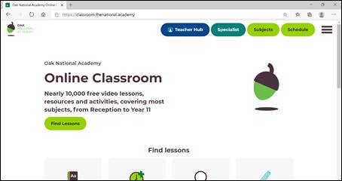
Select ‘Schedule’
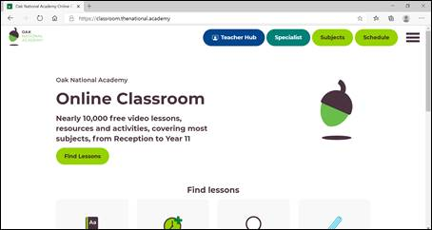
Choose your child’s year group
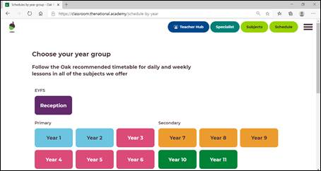
Select Monday - regardless of what day of the week it is, always start on Monday and then continue to work through until your child returns to school
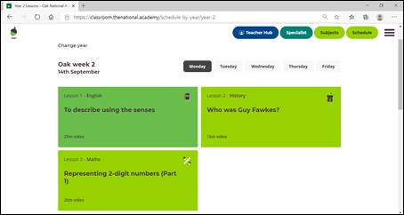
Start with Lesson 1 (and when you’ve done that work your way through to Lesson 3 for that day)
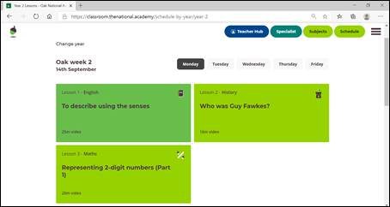
Click on ‘Start Lesson’ and follow on-screen instructions.
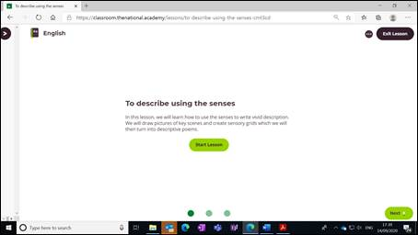
When your lesson is complete remember to return to ‘Schedule’ and go to the next lesson of that same day.
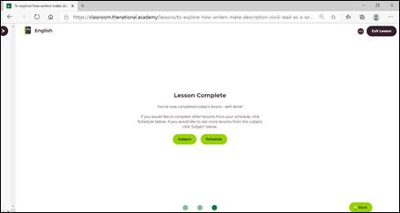
For children with special/additional needs, please click on ‘Specialist’ on the home page
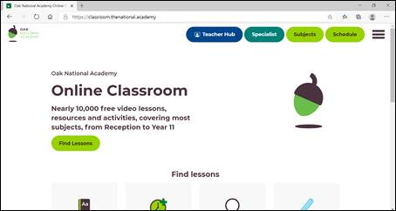
Choose an area of relevance/interest and follow the on-screen instructions
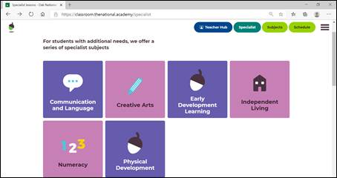
For children with special/additional needs, they also offer a number of therapy-based lessons and resources across occupational, physical, sensory and speech and language.
